CENWP-OD-B 07 August 2024

MEMORANDUM FOR THE RECORD

SUBJECT: 24BON040 MFR CI LPS Pacific Lamprey Mortality

On the morning of 07 August 2024, Project Biologists discovered one Pacific Lamprey mortality in the Cascades Island LPS “Pond” (CI LPS). The fish was scanned for PIT tags, measured, inspected, and returned to the river.

A. Species – Pacific Lamprey (Entosphenus tridentatus)
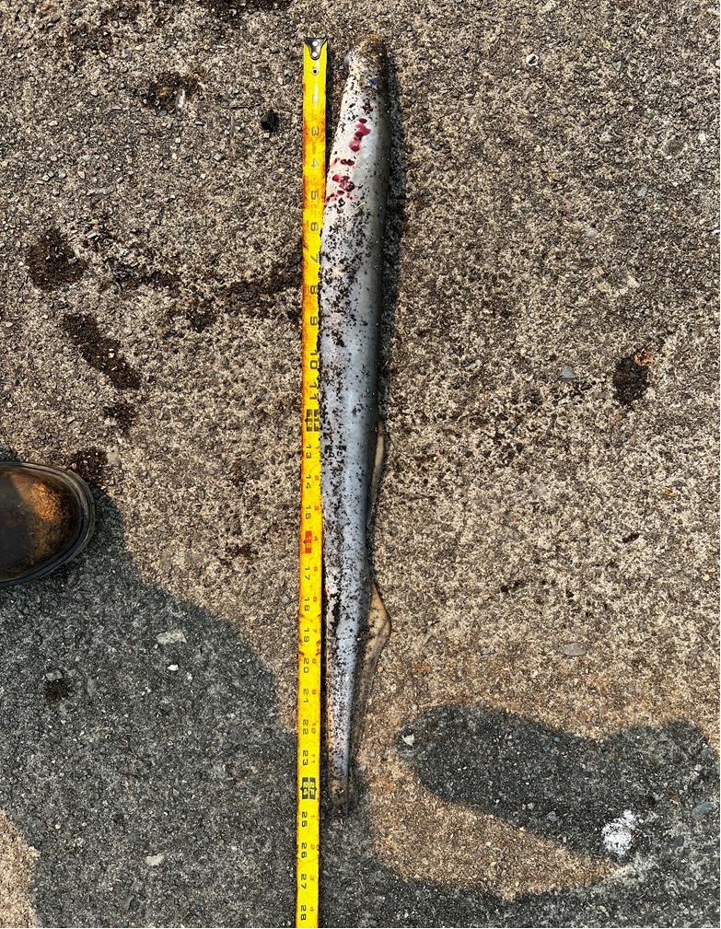
B. Origin – Unknown
C. Length – 63.5cm
D. Marks and tags – None
E. Marks and Injuries found on carcass – Hemorrhaging from gill holes and mouth, no other injuries.
F. Cause and Time of Death – Unknown
G. Future and Preventative Measures – N/A

Sincerely,
Project Fisheries

